Where Newport Harbor High’s 1978 Graduates Came From
by Bill Beamish
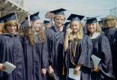
Only a fraction of the students from our class were born in Newport Beach. The majority of classmates were originally from other California cities. The remainder came primarily from other US states. I explored the ’78 Galleon yearbook and discovered nearly all 50 States represented. Our class was also comprised of students born or raised in various foreign countries, including Canada, Iran, France, Belgium, England, Bavaria, Germany, New Zealand, Australia, South Africa, Belgian Congo, Saudi Arabia, Chile, and a number of others. This did not include our class exchange students. Just check the map below!
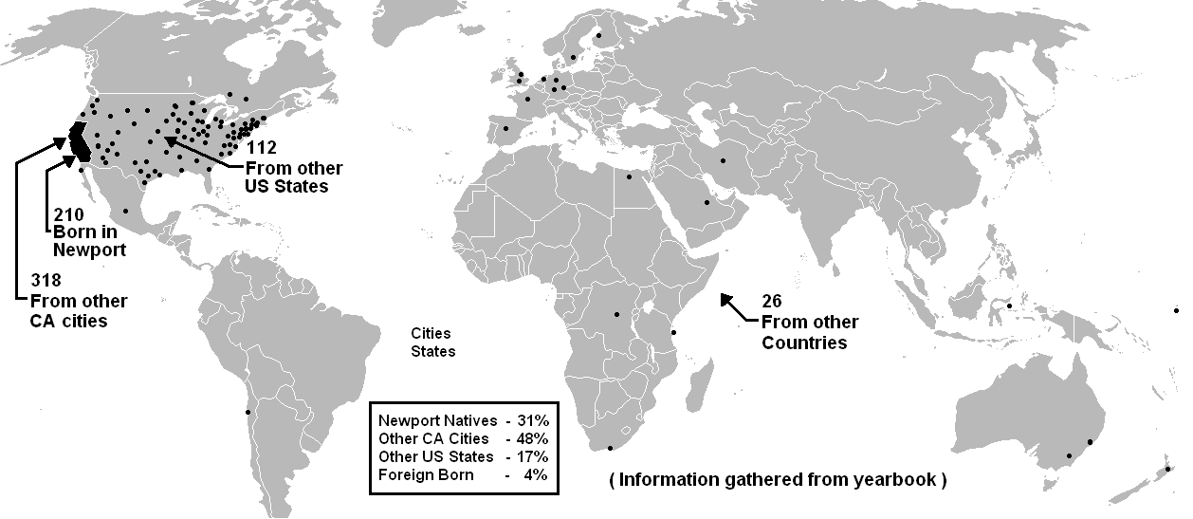
Even though most of our classmates were not born in Newport Beach, the majority were here with their families by the time they were elementary school age. If you follow the names and faces of class alumni back ten years to 1968, you can find a majority of their smiling faces in 2nd-grade photos from the various area grammar schools. Most Harbor High students were, and still are, Ensign Middle School graduates. Ensign is still the primary “feeder school” for NHHS. In turn, Ensign is currently filled primarily with students from the four district elementary schools; Kaiser, Mariners, Newport, and Newport Heights. In our day, Kaiser was a middle school, but slightly smaller than Ensign.

As mentioned above, school populations have changed since we were students, but the current chart below will give you an idea of how NHHS was populated in our day. The individual numbers below are averages based on total current school enrollment. This information was gathered from the Newport/Mesa Unified School District website.
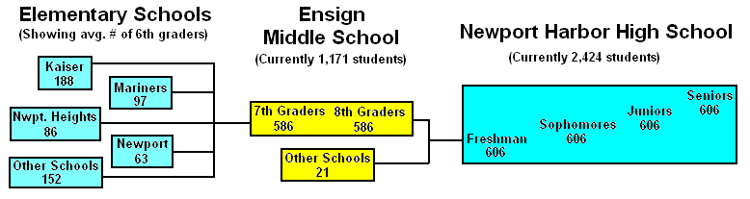
I counted the names of all the 8th graders in our 1974 Ensign Middle School yearbook. We had 445 students in our Ensign graduating class. I also counted the photos of seniors in our ’78 Galleon yearbook and came up with 640 names. Based on these numbers, I am assuming Kaiser Middle School once contributed about 200 students to NHHS each year, but I don’t have an early Kaiser yearbook to verify this guess. I also counted the names of the graduates in our Newport Harbor High School graduation program and came up with 728 names. I’m not sure where the 88 additional graduates came from, but most likely they were a combination of new students, students who missed the yearbook picture day, and students from other grades who earned their diploma that year.

In any event, our 1978 graduating class officially consisted of well over 700 students, possibly the largest graduating class in the history of NHHS. Our class came at the tail end of the baby-boom generation and the Newport/Mesa student population numbers began dropping after 1978, forcing a significant restructuring of the schools. With our huge class population, it is no wonder you can’t remember so many of the faces in the yearbook, let alone the ever-changing faces at the reunions!

Below is a current school district map showing the various Newport-Mesa school zone boundaries. Before I saw this map, I never really knew the areas where the classmates in the different grade schools came from. NHHS also accommodated students from private schools such as Carden Hall. I am assuming the old Kaiser Middle School was once made up primarily of students from Woodland and Whittier Elementary Schools, but I need more historic data to confirm this.
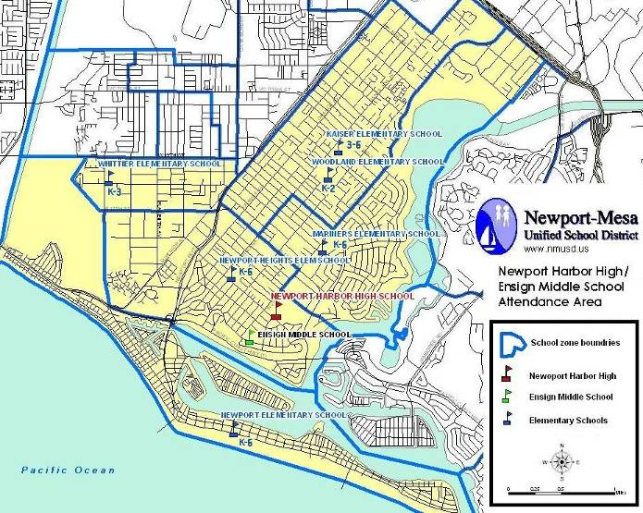
Student populations are in a constant state of flux and it is amazing that school districts can keep up with all of the chaos families “on-the-move” thrust upon them. Tracking all of those students must be a monumental nightmare. I have a much deeper appreciation for this after trying to help contact just a handful of missing alumni. Even with the best search engines, it is sometimes impossible to find current data on our constantly on-the-go alumni.

I certainly don’t consider myself anything special for being both born and raised in Newport Beach, but maybe this helps to explain my current obsession with performing all of this crazy research! I’m a nutty Newport blueblood!

The important thing to remember is that all of our diverse lives converged at one dynamic place and time in one of the most beautiful and hospitable places in the Universe. High school may be just another insignificant little rest stop in the journey of life, but we all shared the experience and survived! Compared to the lives of most people on this planet, we, the people who graduated from Newport Harbor High School in 1978, were pretty darn lucky!

